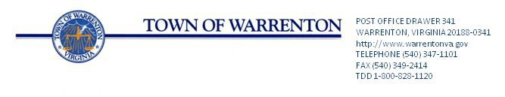

AGENDA

Broadview Avenue Meeting

Police Station Training Room

March 15, 2018
10:00 AM

- Welcome and Introductions – Brannon Godfrey

- Previously Raised Questions/Issues

  - Median Break Between Waterloo Intersection and Church Street
  - Project Phasing
  - Bike Lanes
  - Gold Cup Stop Light Warrants
  - Design Speed
  - Inter-parcel Connections

- Discussion

- Wrap Up/Next Steps

